Inheritance in Java
Inheritance in Java is a mechanism in which one object acquires all the properties and behaviours of a parent object. It is an important part of OOPs (Object Oriented programming system).
Simple Definition of Inheritance
When we construct a new class from existing class in such way that the new class access all the properties and features of existing class called as an inheritance.
The idea behind inheritance in Java is that you can create new classes that are built upon existing classes. When you inherit from an existing class, you can reuse methods and fields of the parent class. Moreover, you can add new methods and fields in your current class also.
Note:
1.In java extends keyword is used to perform inheritance.
2.It provides code reusability.
3.We can’t access private members of class through inheritance.
4.A sub class contains all the features of super class so we should create the object of sub class.
5.Method overring only possible through inheritance.
Inheritance represents the IS-A relationship which is also known as a parent-child relationship.

Why use inheritance in java
- For Method Overriding (so runtime polymorphism can be achieved).
- For Code Reusability.

Terms used in Inheritance
- Class: A class is a group of objects which have common properties. It is a template or blueprint from which objects are created.
- Sub Class/Child Class: Subclass is a class which inherits the other class. It is also called a derived class, extended class, or child class.
- Super Class/Parent Class: Superclass is the class from where a subclass inherits the features. It is also called a base class or a parent class.
- Reusability: As the name specifies, reusability is a mechanism which facilitates you to reuse the fields and methods of the existing class when you create a new class. You can use the same fields and methods already defined in the previous class.

The syntax of Java Inheritance

class Subclass-name extends Superclass-name
{
//methods and fields
}

Types of java Inheritance

Supported by java
1.Single/Simple Inheritance
2.Multilevel Inheritance
3.Hierarchical Inheritance

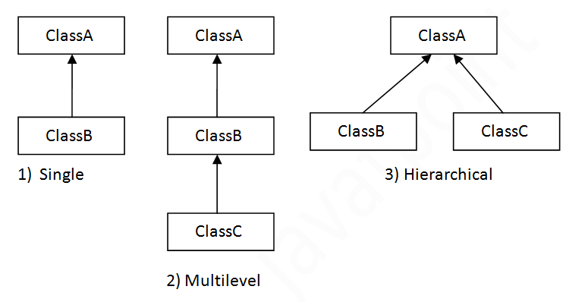

Not-supported by java
1.Multiple Inheritance
2.Hybrid Inheritance
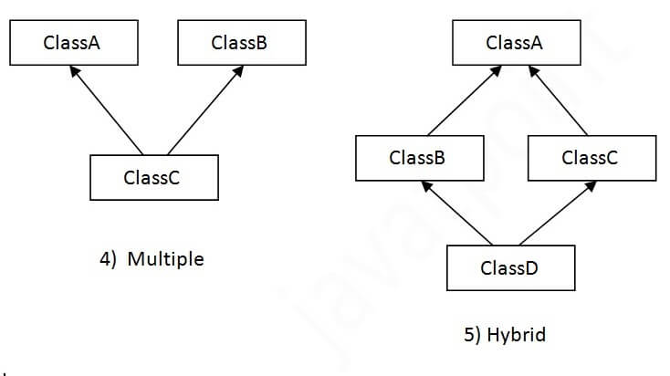

Single Inheritance
Single inheritance is nothing but which contains only one super class and only one sub classes.
Syntax:
class A
{
//block of code
}
class B extends A
{
//block of code
}

Multilevel Inheritance
In multilevel inheritance we have only one super class and multiple sub classes.
Syntax:
class A
{
//block of code
}
class B extends A
{
//block of code
}
class C extends B
{
//block of code
}
class D extends C
{
//block of code
}

Hierarchical Inheritance
An inheritance which contains only one super class and multiple sub classes directly extends super class called hierarchical inheritance.
Syntax:
class A
{
//block of code
}
class B extends A
{
//block of code
}
class C extends A
{
//block of code
}

Multiple Inheritance
Multiple Inheritance is the process in which a subclass inherits more than one superclass.
Java doesn't support Multiple Inheritance, but we can use interfaces (instead of classes) to achieve the same purpose.
In the below image, we can observe that Class C(sub-class) inherits from more than one superclass i.e., Class A, Class B. This is the concept of Multiple Inheritance.
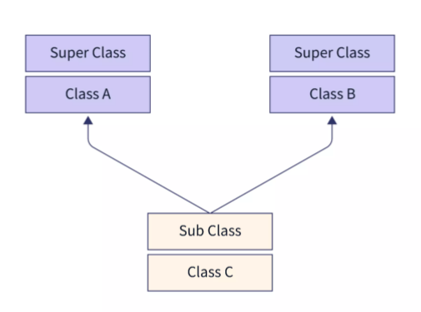
Hybrid Inheritance
Java does not support multiple inheritance; hybrid inheritance is also not possible in Java. Just like multiple inheritance you need to achieve this using interfaces.

